**Tandem, final report**

**Gallery Oldham (UK) and SMAAK (NL)**

**April 2016-July 2017**

**What was the Tandem?**

Our Tandem was between SMAAK and Gallery Oldham. SMAAK is a small arts organisation based in Amersfoort in the Netherlands, Gallery Oldham is a large, public sector art gallery and museum situated in Oldham, UK. Both organisations work on arts based projects with older people.

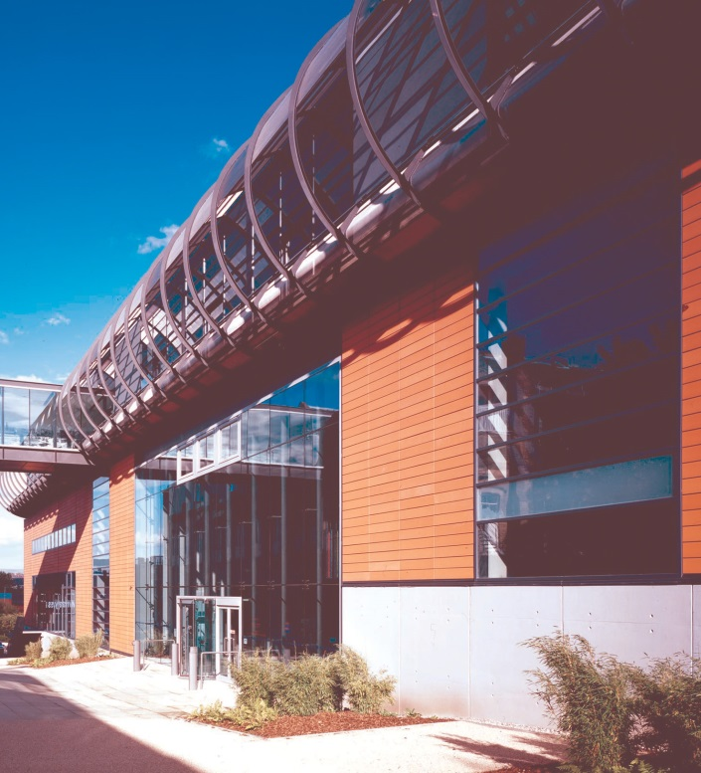

***Gallery Oldham***

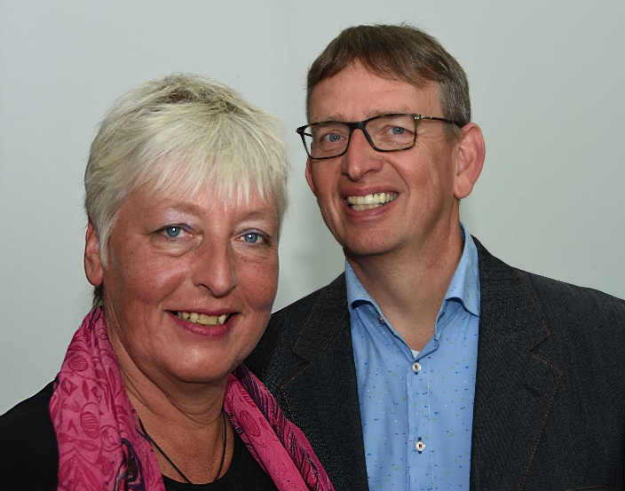

***SMAAK, Marlies and Andries***

**Why did we get together?**

After the initial meeting in Rotterdam (Joy and Marlies) we discovered that although we work differently, both organisations wanted to continue to expand the work we do with older people. We discussed various ideas for different projects. Some of them were very ambitious! What we did discover was that we had little knowledge of how our different organisations worked, what were the pros and cons of each? And, how we could learn from each other and maybe inform each others practice. Our main differences were these:

* Gallery Oldham is a large art gallery and museum. A building with spaces for exhibitions, workshops and activities. A structured team of staff (curators, education and Outreach, Archives, Arts Development, Front of House, Technicians and Maintenance). SMAAK is an small organisation, managed by two people. There is no building to oversee and no other teams to take into account when making decisions and planning work.
* Gallery Oldham works with a mixture of core council funds and grant monies from various funders and also makes charges for some paid for activities. SMAAK seeks funding from funding institutions and businesses.
* Gallery Oldham concentrates its work for older people both in-house at the gallery and on an outreach basis in community and care home settings. This work mainly consists of 1-2 hour long sessions based on arts, reminiscence, wellbeing etc. SMAAK do not have a building and therefore concentrate their energies on work that can be delivered in the community.
* There are also differences in how we are employed and how we are paid. Joy and Glenys are salaried employees and are involved in a number of different projects and areas of work. These range from babies, children, families, schools and colleges and of course older people. Andries and Marlies are the directors of SMAAK. Their income depends on the success of fundraising.

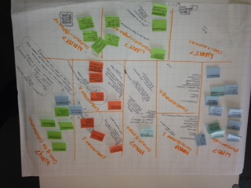

***Image of Marlies and Joys initial ideas in Rotterdam***

**What was it about?**

We decided to organise an exhibition at Gallery Oldham to showcase the work of SMAAK. This would involve the production of 11 pop up banners, 2 films and printed material (double sided postcards) to consult with visitors/stakeholders and gather feedback. We aimed to use the exhibition as way of engaging stakeholders from Oldham in the concept of SMAAK and more importantly to see if there was the appetite to bring the concept to care homes and housing providers etc in Oldham. We decided to install the exhibition at Gallery Oldham during Dementia Awareness week (15th May to 21 May 2017) as there was lots of activity planned in the town and we could also ‘piggy back’ on external marketing and promotion.

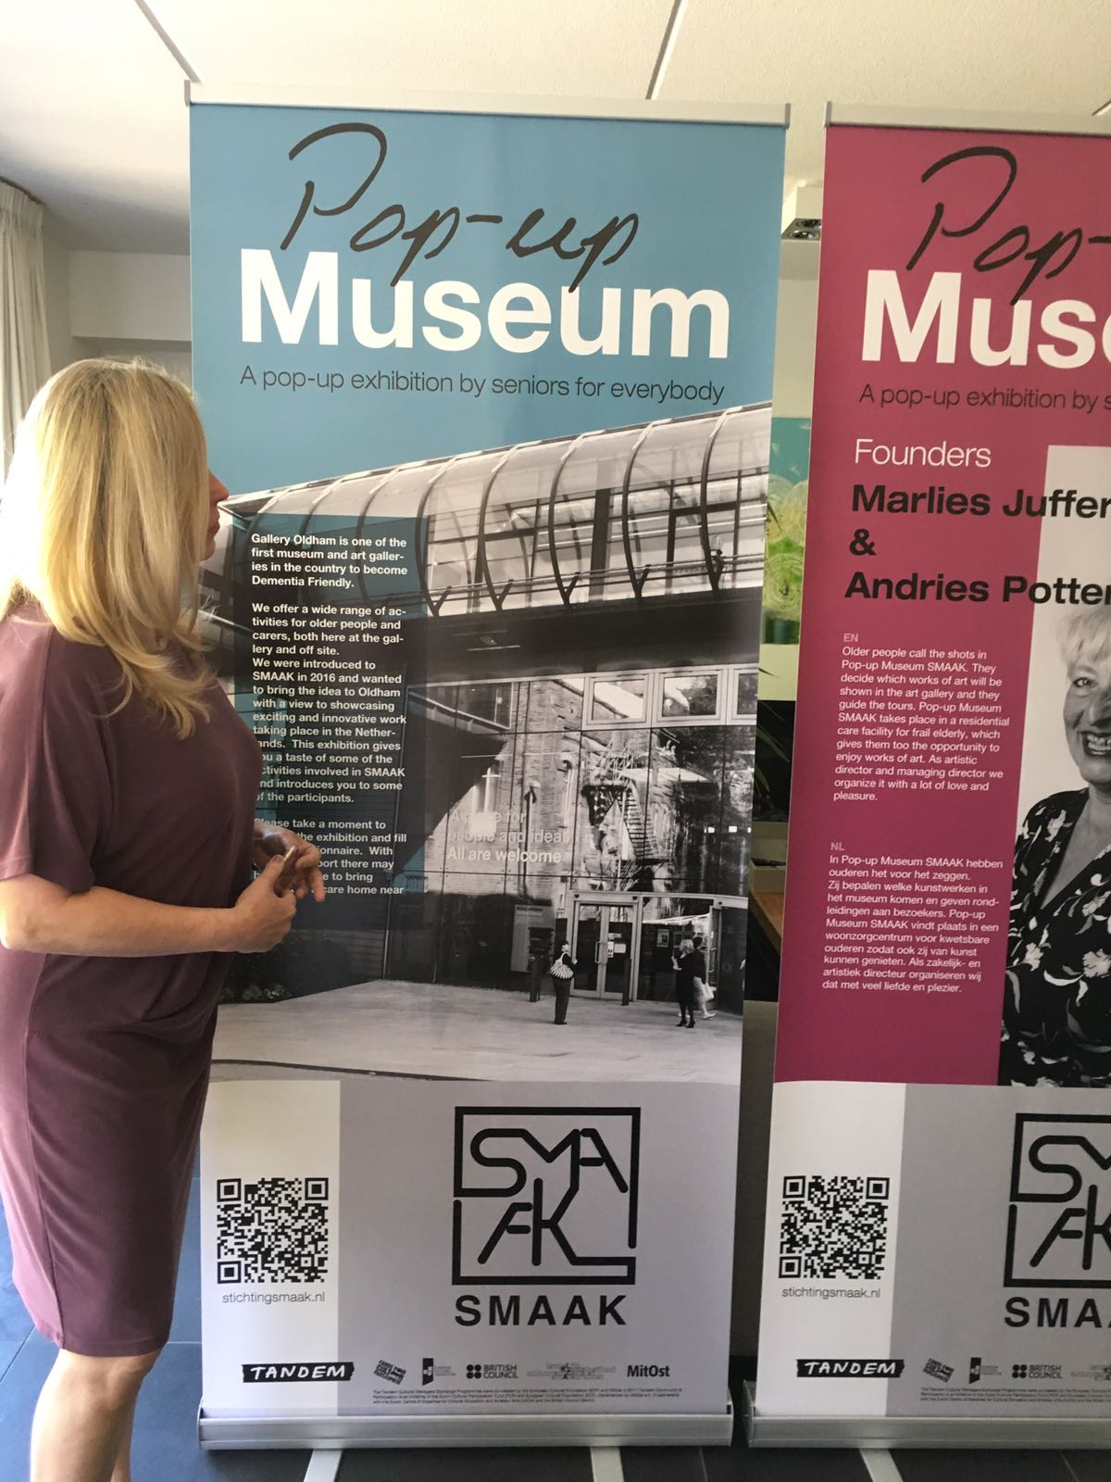

***Final banner sign off***

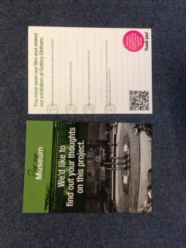

***Double sided response postcard***

**How and why did we decide to do this?**

When we realised the limitations of the budget we soon scaled down some of our original ideas. Both organisations wanted to see something tangible emerge from the Tandem. We didn’t just want to complete our placements and have an ‘exchange of ideas’. We also wanted to ensure that there was some real legacy to our Tandem. We had an honest conversation about what each organisation wanted.

For gallery Oldham it was to raise awareness of ground breaking arts projects delivered in Europe, as we felt much of the work in Oldham for older people had become stale. Also, the SMAAK concept of involving the whole community in the Pop-up Museum was interesting as was the partnerships SMAAK had with artists and with individuals (curators, volunteers etc) involved. Gallery Oldham were keen to see how relationships develop and how meaningful partnerships can be made. Gallery Oldham also wanted to learn how to approach businesses/care home organisations/housing providers with ideas for funding as this is something SMAAK have been successful with.

For SMAAK it was to find out if the concept of Pop-up Museum SMAAK was transmissible other organisations – could the project travel and could it be adapted to work outside the Netherlands? SMAAK also wanted to learn first-hand how a large organisations work and what issues need to be considered when partnering with larger institutions to create wider opportunities for community engagement

**What did we do to make this a reality??**

After much thought we decided to hold 3 placements and to minimise the money spent we hosted each other at our homes. Also we tried, where possible, coincide our placements with TANDEM meetings in the UK and the Netherlands to minimise travel costs.

Our first placement was in October 2016 when Joy visited Amersfoort to see first-hand the Pop-up Museum in the care home in Amersfoort. The Pop-up Museum ran for the month of October and Joy was able to speak to all participants. Spending time with volunteers, curators, care home director, staff and residents and families. Meetings with artists, funders and education teams in other Dutch museums were also arranged.

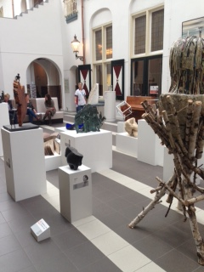

***Pop-up Museum SMAAK at PB House, Amersfoort. Oct 2017***

Our second placement coincided with the TANDEM meeting in Leeds (14th Feb to 16 Feb 2017). Marlies and Andries stayed at Joys and spent two days familiarising themselves with Gallery Oldham. They met with all the different teams and were able to develop a knowledge of how a large organisation is organised an how it functions. Marlies and Andries were also introduced to the space designated for the banner exhibition and we had much discussion on how the area works, both as an exhibition space and also as a public thoroughfare. We also discussed how many banners we needed, who should be invited to feature, who should design and produce the banners and feedback postcards, which Oldham stakeholders we should invite to the planned event and what we wanted to achieve at the end of the exhibition.

From February to May there was much activity in our TANDEM. We had Skype calls and numerous email communications. We had to agree who’s story we wanted to tell on the banners, word count, images, etc. Joy was able to use her experience in interpretation and access to suggest ways in which to keep the meaning clear and to the point with a 200 word max. We also had to decide what information we wanted to gather from our feedback/consultation postcards. Again, Joy was able to suggest 3 simple questions that would be easy for people to understand and respond to. Andries and Marlies had employed a filmmaker to film the Pop-up Museum SMAAK and this was then transcribed into English. Joy edited and proofed the banners, postcard and the films.

Our third placement was in May 17th to Friday 19th May 2017. Marlies and Andries came to stay at Joys and brought with them all the banners, postcards and films for the pop-up banner exhibition. We installed the banner exhibition in the Gallery foyer to maximise exposure to the information. We had planned for these dates as it coincides with Dementia Awareness Week in the UK and Joy had organised an event to be held at the Gallery on 19th May. The event was aimed at stakeholders, older people, housing organisations and carers and care home providers. Organisations were invited to have a stall in the ‘market place’ area, these includes AGEUK, Alzheimers Society, Housing 21, Making Space, Oldham Memory Service, Home Instead, Care Mark. Each of these organisations works with older people or provides services for older people. The event was hosted in partnership with Making Space who are an organisation with many projects for older people in the various communities in Oldham. The market place was situated in the large Education Suite at Gallery Oldham. In the foyer of Gallery Oldham we had the pop up banner exhibition that people passed through on their way into the Education Suite, this maximised footfall and exposure to the exhibition. We were also there to interact with people to gather feedback. We also arranged for other artists who had worked with Gallery Oldham previously to deliver sessions for people attending the event to drop in to. We advertised the event to the widest possible audience, Making Space distributed flyers and posters to their contacts and Gallery Oldham also publicised the event on its website, and via Twitter and Facebook. The role of our Tandem on the day was to engage with people, introduce them to the concept of SMAAK and to encourage people to fill in our feedback postcards.

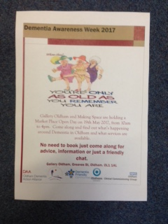

***Poster to advertise Dementia Awareness Event. May 2017***

On the day of the event we had approx. 543 visitors to the Gallery and approx 200 of those came to attend the event. So 543 visitors accessed the Pop-up banner exhibition and had the opportunity to feedback on our ideas. Of the 200 people who attended the event the verbal feedback was positive. The exhibition was in place for 3 days and visitor figures to the Gallery for those 3 days were: Thursday 18 May = 420, Friday 19 May = 543, Saturday 20th May = 500. In total 1463 people accessed our Pop-up banner exhibition!

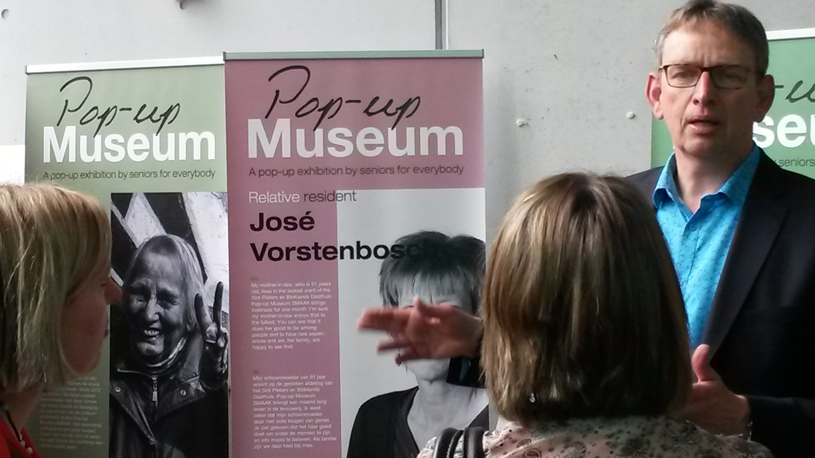

***Andries explains the concept of Pop-up Museum SMAAK***

During the 3 days we were able to gather 150 completed written responses. These were posted in the post box we had installed as part of the pop-up banner exhibition. It is important to note that most of the responses were received whilst the Tandem team were present and physically engaging with people. On the days that we weren’t in situ there were fewer responses posted.

**What happens next? What’s the ‘legacy’?**

The responses were all positive, people wanted to see a SMAAK-like activity happening in Oldham and the majority of people thought that the activities should be paid for by either the local council, or from care homes themselves. For Gallery Oldham, this is a good result. The feedback responses will be collated and we will then be able to make representation to care home businesses and our local council to seek support in taking the work forward.

**Was the Tandem a success?**

Our Tandem was a resounding success. We achieved all we set out to do in our collaboration project plan.

For Gallery Oldham the chance to showcase innovative work from Europe was useful to promote the Dementia Awareness event and so bring more people in. Visitors were interested in work with older people in the Netherlands, particularly those visitors and stakeholders who had a vested interest in older people. Gallery Oldham have been able to make significant progress on building relationships with Housing 21. This local supported housing organisation have expressed interest in working with Gallery Oldham to scope the possibility of delivering a SMAAK pop-up exhibition at one of their larger supported accommodation schemes. Although it will be on a smaller scale than the project at the PB House in Amersfoort it will pilot the idea and concept. Gallery Oldham and Housing 21 are currently working together to introduce residents of the scheme to our staff and collections by holding informal ‘getting to know you’ sessions held during monthly coffee mornings. They hope that if enough residents are committed it will give them a stronger case for applying for grants and releasing budget from the national Housing 21 budget to realise a SMAAK-like exhibition at the supported housing scheme. Gallery Oldham will collate all the feedback responses from the Pop-up banner exhibition and work with Housing 21 to present a joint presentation to funders outlining the possibilities of working in partnership. Feedback from residents during the coffee morning sessions is also looking extremely positive so hopefully Oldham may have its very own Pop Up SMAAK exhibition. Of course it is early days in this process but Gallery Oldham will work with Housing 21 to try and make the concept a reality.

The Tandem was very successful for SMAAK. SMAAK learned how to work together with a large museum. They experienced the procedures and the dynamics of Gallery Oldham. The museums in Amersfoort were impressed by the Tandem project and the international activities of SMAAK. Being part of Tandem and working with a partner in England raised the status of SMAAK. These museums in Amersfoort are much more willing now to cooperate with SMAAK. The feedback from visitors and stakeholders SMAAK met at the Pop-up banner exhibition was very usefull for SMAAK. SMAAK learned about organisations in the UK who work with seniors and their vision on art. Also they experienced enthusiasm about the concept of the Pop-up Museum SMAAK. This concept is new in the UK, and apparently attractive to organisations who are looking for new ways of working with seniors. The enthusiasm strengthen the energy and power of the foundation SMAAK. They found a potential new market in the UK.

August 2017

Joy Thorpe

Marlies Juffermans